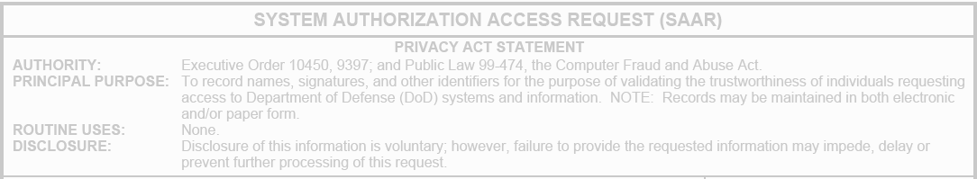  **MCU SAAR INSTRUCTIONS**

1. **Type today’s date in the Date field.**



**A**

**.**

**Ty**

**pe in**

**today**

**’**

**s**

**DO NOT CHANGE**

**DO NOT CHANGE**

**DO NOT CHANGE**

1. **Type your name (example…Smith, Bill E.) in Block 1.**
2. **Type your department/school code (example…CSC, EWS or VPAA) in Block 3.**
3. **Type your office or school telephone number in Block 4.**



**DO NOT CHANGE**

**C.**

**Type**

**your department or school code**

**D.**

**Type**

**your office or school telephone**

**B.**

**T**

**ype**

**your name**

1. **Type your title, grade and rank in Block 6 (*HR Rep/Contractor* … *IT Tech/E4/Cpl*).**
2. **Verify or change your citizenship and designation in Block 8 and Block 9.**

***(FN = Foreign National. Volunteers & Interns select the Civilian radio button)***

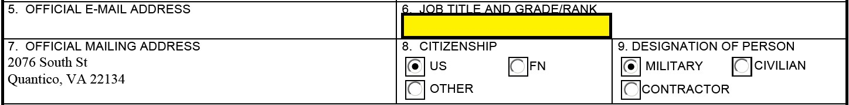

**DO NOT CHANGE**

**E.**

**Type**

**your job title, grade and rank**

**F.**

**Verify or change if needed**

**DO NOT CHANGE**

1. **Type your CyberM or CyberC completion date in Block 10. *Refer to MarineNet at*** [*https://www.marinenet.usmc.mil*](https://www.marinenet.usmc.mil/)***to accomplish the required training prior to entering the date*.**
2. **Type N/A in Block 12 if it is not there already. *(Must be done before digitally signing***

***Block 11)***

1. **Digitally sign Block 11 & Page 3 with your CAC.**

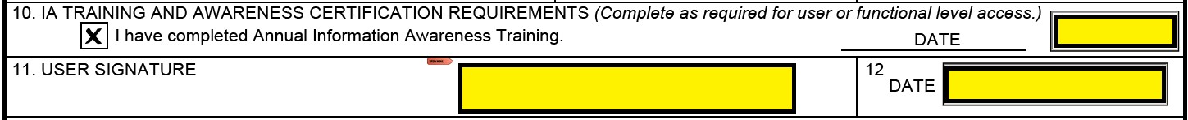

**G.**

**Type**

**the date**

**I.**

**Digitally sign with CAC**

**DO NOT CHANGE**

**H.**

**Type N/A**

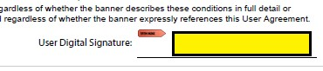

Bottom of Page three